练习1

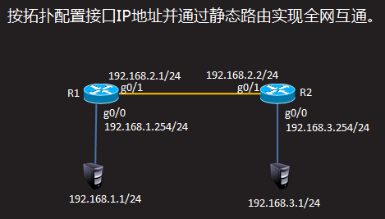

R1配置

Router>enable

Router#configure terminal

Router(config)#interface gigabitEthernet 0/0

Router(config-if)#ip address 192.168.1.254 255.255.255.0

Router(config-if)#no shutdown

Router(config-if)#exit

Router(config)#interface gigabitEthernet 0/1

Router(config-if)#ip address 192.168.2.1 255.255.255.0

Router(config-if)#no shutdown

Router(config-if)#exit

Router(config)#ip route 192.168.3.0 255.255.255.0 192.168.2.2

R2配置

Router>enable

Router#configure terminal

Router(config)#interface gigabitEthernet 0/0

Router(config-if)#ip address 192.168.3.254 255.255.255.0

Router(config-if)#no shutdown

Router(config-if)#exit

Router(config)#interface gigabitEthernet 0/1

Router(config-if)#ip address 192.168.2.2 255.255.255.0

Router(config-if)#no shutdown

Router(config-if)#exit

Router(config)#ip route 192.168.1.0 255.255.255.0 192.168.2.1

练习2

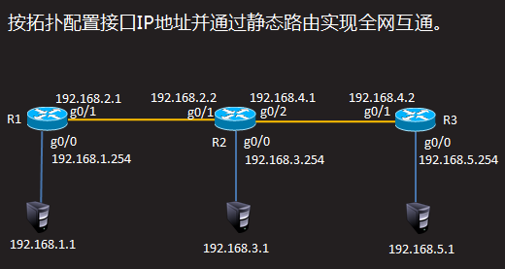

注：以下配置需要在练习1的基础上完成

R1配置

Router(config)#ip route 192.168.4.0 255.255.255.0 192.168.2.2

Router(config)#ip route 192.168.5.0 255.255.255.0 192.168.2.2

R2配置

Router(config)#interface gigabitEthernet 0/2

Router(config-if)#ip address 192.168.4.1 255.255.255.0

Router(config-if)#no shutdown

Router(config)#ip route 192.168.5.0 255.255.255.0 192.168.4.2

R3配置

Router>enable

Router#configure terminal

Router(config)#interface gigabitEthernet 0/0

Router(config-if)#ip address 192.168.5.254 255.255.255.0

Router(config-if)#no shutdown

Router(config-if)#exit

Router(config)#interface gigabitEthernet 0/1

Router(config-if)#ip address 192.168.4.2 255.255.255.0

Router(config-if)#no shutdown

Router(config-if)#exit

Router(config)#ip route 192.168.1.0 255.255.255.0 192.168.4.1

Router(config)#ip route 192.168.2.0 255.255.255.0 192.168.4.1

Router(config)#ip route 192.168.3.0 255.255.255.0 192.168.4.1

练习3

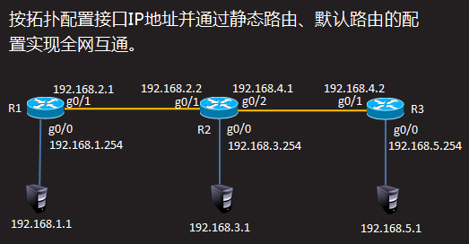

注：以下配置需要在练习2的基础上完成

R1配置

Router(config)#no ip route 192.168.3.0 255.255.255.0 192.168.2.2

Router(config)#no ip route 192.168.4.0 255.255.255.0 192.168.2.2

Router(config)#no ip route 192.168.5.0 255.255.255.0 192.168.2.2

Router(config)#ip route 0.0.0.0 0.0.0.0 192.168.2.2

R3配置

Router(config)#no ip route 192.168.1.0 255.255.255.0 192.168.4.1

Router(config)#no ip route 192.168.2.0 255.255.255.0 192.168.4.1

Router(config)#no ip route 192.168.3.0 255.255.255.0 192.168.4.1

Router(config)#ip route 0.0.0.0 0.0.0.0 192.168.4.1

练习4

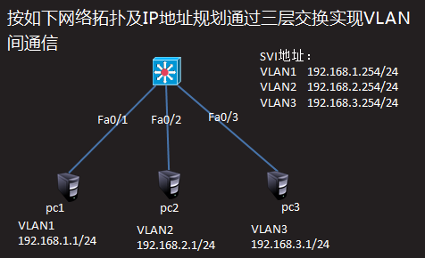

三层交换机配置

Switch>enable

Switch#configure terminal

Switch(config)#interface vlan 1

Switch(config-if)#ip address 192.168.1.254 255.255.255.0

Switch(config-if)#no shutdown

Switch(config-if)#vlan 2

Switch(config-vlan)#vlan 3

Switch(config-vlan)#exit

Switch(config)#interface vlan 2

Switch(config-if)#ip address 192.168.2.254 255.255.255.0

Switch(config-vlan)#exit

Switch(config)#interface vlan 3

Switch(config-if)#ip address 192.168.3.254 255.255.255.0

Switch(config-vlan)#exit

Switch(config)#ip routing //开启路由功能

练习5

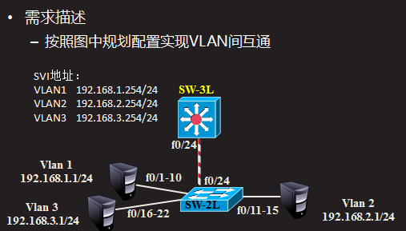

注：以下配置需要在练习4的基础上完成

三层交换机配置

Switch(config)#interface fastEthernet 0/24

Switch(config-if)#switchport trunk encapsulation dot1q

Switch(config-if)#switchport mode trunk

二层交换机配置

Switch>enable

Switch#configure terminal

Switch(config)#interface range fastEthernet 0/11-15

Switch(config-if-range)#switchport access vlan 2

Switch(config-if-range)#exit

Switch(config)#interface range fastEthernet 0/16-22

Switch(config-if-range)#switchport access vlan 3

Switch(config)#interface fastEthernet 0/24

Switch(config-if)#switchport mode trunk

练习6

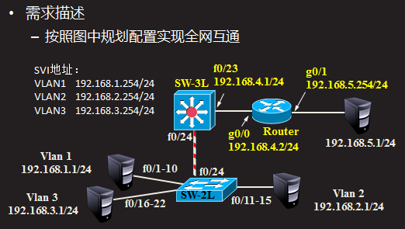

注：以下配置需要在练习5的基础上完成

三层交换机配置

Switch(config)#interface fastEthernet 0/23

Switch(config-if)#no switchport

Switch(config-if)#ip address 192.168.4.1 255.255.255.0

Switch(config-if)#exit

Switch(config)#ip route 0.0.0.0 0.0.0.0 192.168.4.2

路由器配置

Router>enable

Router#configure terminal

Router(config)#interface gigabitEthernet 0/0

Router(config-if)#ip address 192.168.4.2 255.255.255.0

Router(config-if)#no shutdown

Router(config-if)#exit

Router(config)#interface gigabitEthernet 0/1

Router(config-if)#ip address 192.168.5.254 255.255.255.0

Router(config-if)#no shutdown

Router(config-if)#exit

Router(config)#ip route 192.168.1.0 255.255.255.0 192.168.4.1

Router(config)#ip route 192.168.2.0 255.255.255.0 192.168.4.1

Router(config)#ip route 192.168.3.0 255.255.255.0 192.168.4.1

练习7

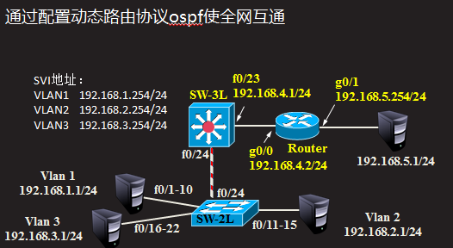

注：以下配置需要在练习6的基础上完成

三层交换机配置

Switch(config)#no ip route 0.0.0.0 0.0.0.0 192.168.4.2

Switch(config)#router ospf 1

Switch(config-router)#network 192.168.1.0 0.0.0.255 area 0

Switch(config-router)#network 192.168.2.0 0.0.0.255 area 0

Switch(config-router)#network 192.168.3.0 0.0.0.255 area 0

Switch(config-router)#network 192.168.4.0 0.0.0.255 area 0

路由器配置

Router(config)#no ip route 192.168.1.0 255.255.255.0 192.168.4.1

Router(config)#no ip route 192.168.2.0 255.255.255.0 192.168.4.1

Router(config)#no ip route 192.168.3.0 255.255.255.0 192.168.4.1

Router(config)#router ospf 1

Router(config-router)#network 192.168.4.0 0.0.0.255 area 0

Router(config-router)#network 192.168.5.0 0.0.0.255 area 0